Exploring RapidMiner Plugins

Predictive Analytics

Dr Muhammad Iqbal

RapidMiner has a number of great operators, however sometimes we may find the need to work with text. When this challenge arises we must look at some of the other plugins that RapidMiner has to offer on the RapidMiner Marketplace

Inside the Help menu at the top of RapidMiner you will see a link to the Marketplace. Click on this link to open up the plugin dialog.
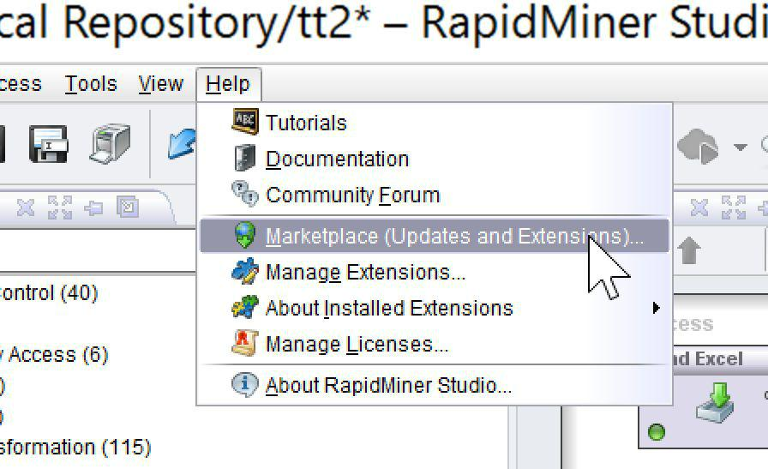
Once inside of this dialog, click on the “Top Downloads” tab and install the Text Processing plugin and the Web Mining plugin. We will be using both of these.
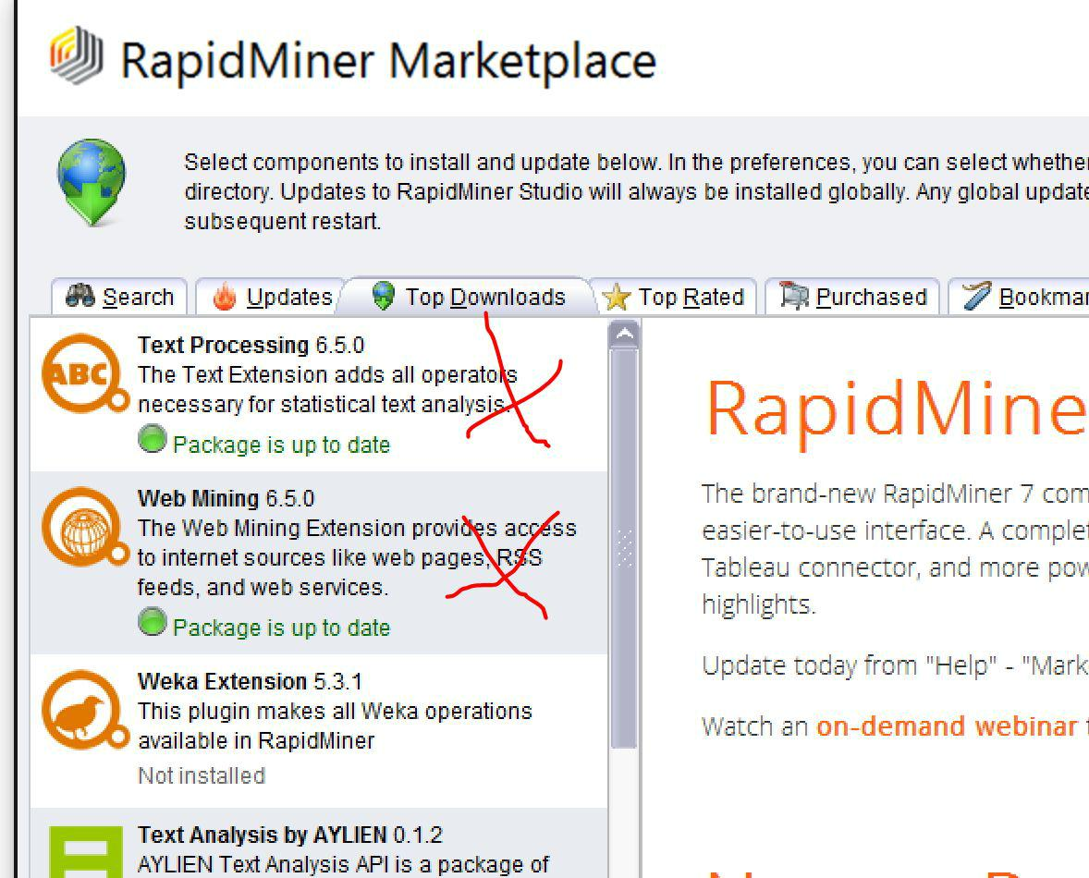

The Web Mining plugin is focused upon purely downloading web pages and it comes with very little additional tools for working with the text that we will be downloading. For this reason, the Text Processing plugin has all the additional tools that we will need for manipulating the text.
Getting started

From the left hand side inside of the Web Mining folder drag across an instance of the Get Page operator.
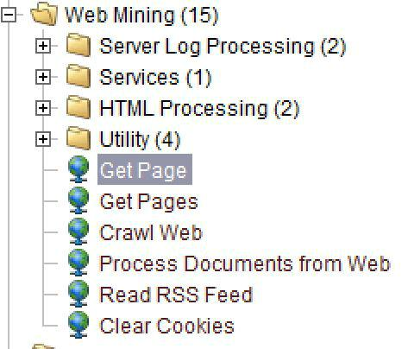
After you have dragged across the Get Page operator click on the operator and look to the right hand side to see all of the different options that can be set for this operator.


The one that we will be most interested in is the very first parameter, url. Add a website address into this box. In the picture shown below we have pointed the Get Page operator to download the ​www.cct.ie​webpage.
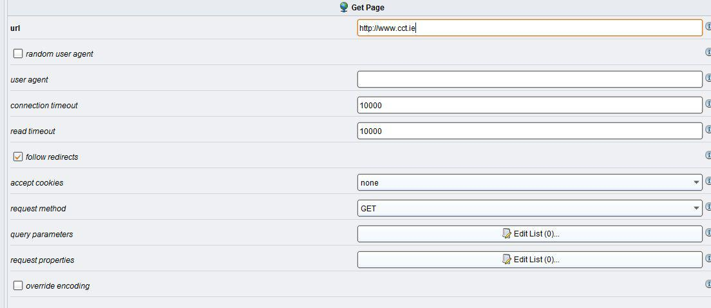
After we have set the url parameter, we can then connect the output of the right hand side of the operator to connect to the sink on the right hand side of the designer. This step is important as it will allow us to see the output of the operator.
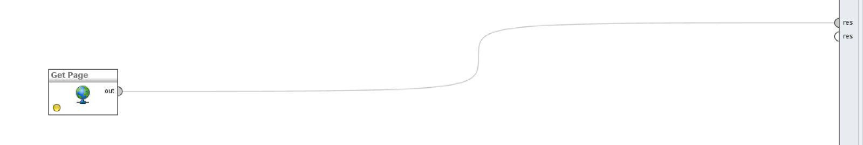

Press the play button at the top of RapidMiner to run the process and switch to the Results view. In this case you can see that it has download the content and displayed it to us.
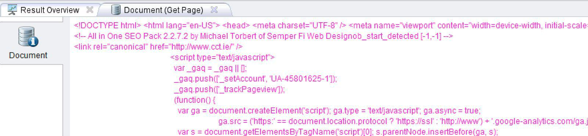

The issue that becomes apparent during this step is that all of the JavaScript code along with the HTML of the webpage have also been retrieved. The task now becomes how to remove all of this additional data and only leave the text from the page.
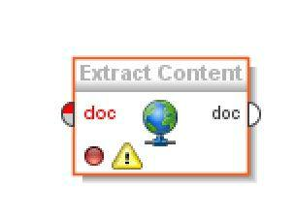

We can use the extract content operator. This allows to us take the website which we have just downloaded and only extract the text from the document instead of taking all of the HTML and JavaScript tags also.

Text Processing Plugin

Now that we have downloaded the webpage we will move to the Text Processing plugin to perform some basic tasks on the data. It is important to remember that when working with text documents, the data type is not the classic ExampleSet that we normally use with RapidMiner, all data is treated as a Document. You see that all of the input and outputs from each operator are of type “doc”.
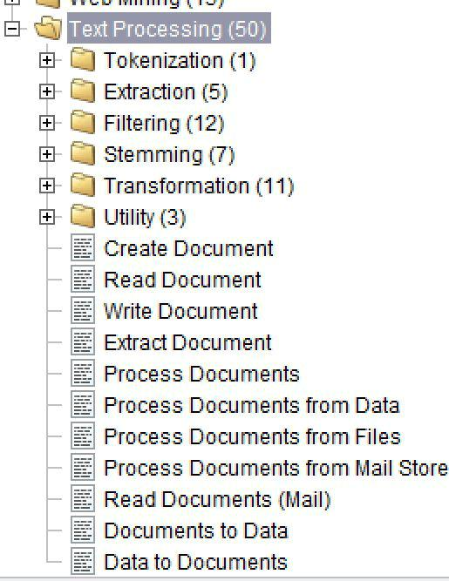
Text Processing Operators

In this section we will review some of the text processing operators that are of interest to us during this task.

Stemming

The stemming algorithm is designed to remove a word back to its stem. This prevents multiple words which have different endings such as colleges and college from being treated as different words. It is often the case that this would be done to get a complete total of how many times a specific word was mentioned in a document.
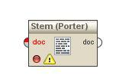

Another example of this is bombings and bomb, they are both based upon the same word so any occurrences of the term bombings would be simply be shown as bomb.

Stopwords

When processing text there are a number of different words that are not useful to the task at hand. This is the case for words which do not actually describe the content. An example of stopwords include a, the, him, her, was, our. They are all small terms which will not be useful during the complete data mining task. We apply a Filter Stopwords when we want to remove these from the document any only leave larger more meaningful terms. Their is not official list of stopwords, each different vendor often makes their own list.
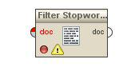

Tokenize

When working with documents we often need to break the document down into smaller parts to process. Sometimes we can use a ngram approach where the total number of terms is defined.

If we have the length of tokens to be 3, all of the sentences will then be broken up into sentences that are only three words long. Sometimes we may also token based upon fullstops, an option for this also exists. Each of the fullstops in the document are considered to be the breaking point where the documents are segmented into different chunks.
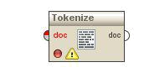

Filter by POS

Sometimes we may have an understanding on the types of word we wish to remove from a document. In this case we can use the filter tokens by part of speech operator. In the settings for this operator we define the terms which we want to remove or keep in the document.


In this case, we are using the Penn Treebank tagger to identify these terms. So we will need to use the list of Penn Treebank tags. A list of the tag names can be found below.
